Student Name: Your full name
Student ID: Your Student ID

Query Appendix

Question 1
- Query
SELECT
customer_id,
DATE_DIFF(CURRENT_DATE(), MAX(trans_date), DAY) AS recency_score,
COUNT(DISTINCT trans_date) AS frequency_score,
SUM(tran_amount) AS monetary_score
FROM `***(your path).retail_date_transactions`
GROUP BY
customer_id;
- Result Screenshot
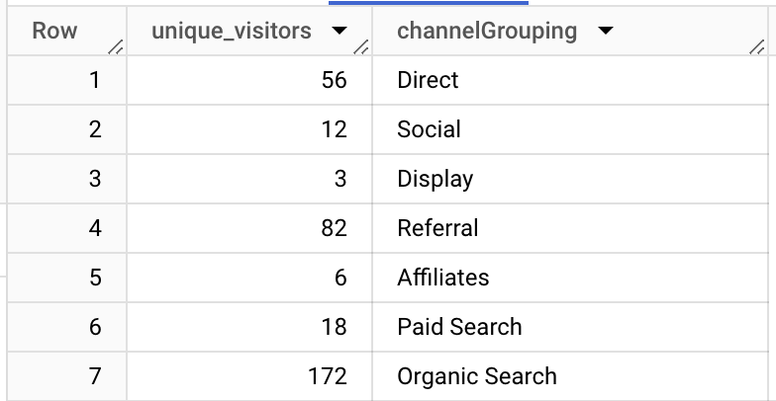

Question 2
- Query
- Result Screenshot

Question 3
- Query
- Result Screenshot

Question 4
- Query
- Result Screenshot

